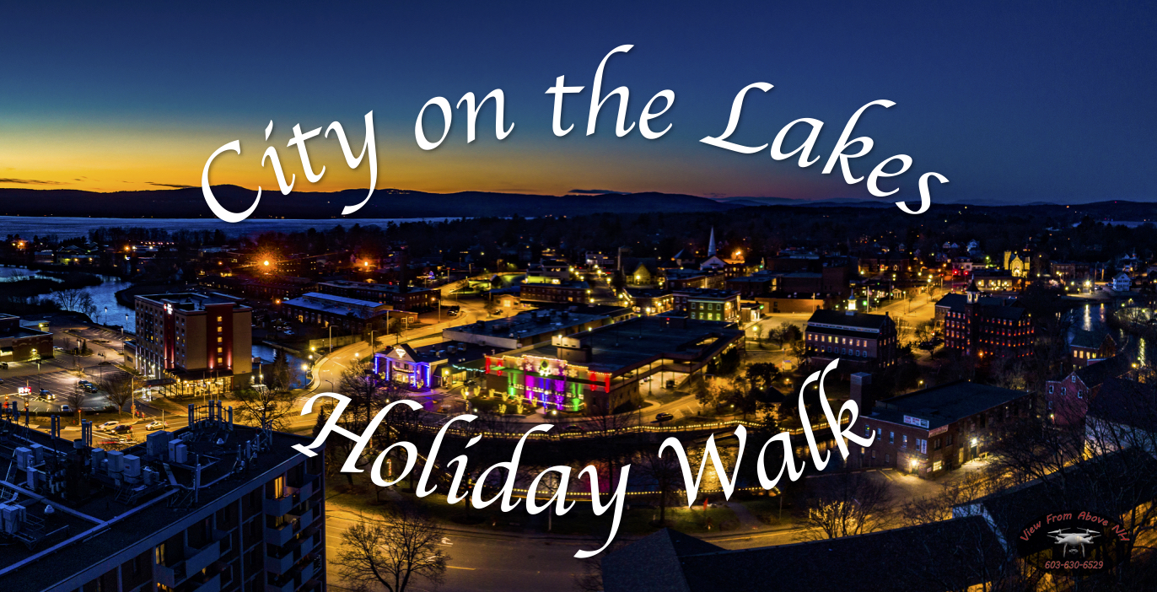

Share the Holidays with the City on the Lakes by decorating a Christmas Tree for everyone to enjoy
Sponsor a Tree: $65 for a tree pre-lit to decorate. Payments may be made by check or by credit card online.
How it works: Individuals, organizations, businesses and families can sponsor a tree that will be set up and lit in Rotary Park by November 21, 2026. All you have to do is show your Laconia holiday spirit by decorating your tree with family, friends, or co-workers prior to the Holiday Parade on November 28, 2026. Please place decorations securely on trees - if not secured they may detach due to weather. Celebrate Laconia is not responsible for any missing, damaged or stolen ornaments/decorations. Any decorations not removed by January 3, 2027, will be discarded.
Lights Festival, Parade, and Lighting Ceremony: November 28, 2026, from 9:00am – 8:00pm come out and enjoy walking through the trees and watching the Holiday Parade. The parade will start at 4:30pm and Santa will light the trees at the end of the Parade.
To Sponsor a tree to decorate: Please Register online or mail checks (payable to Celebrate Laconia) with below registration to Celebrate Laconia, PO Box 6502, Laconia, NH 03247. If you have any questions, please contact Celebrate Laconia at connect@celebratelaconia.org



Name: __________________________________________________________________
Name on Tree Sign: ________________________________________________________
Phone#: _______________________ Email: _____________________________________

I agree to send a team to decorate the tree before parade on November 28, 2026. I also agree to remove decorations at the end of the Holiday Walk between December 26, 2026- January 3, 2027.

Celebrate Laconia, PO Box 6502, Laconia, NH 03247 • celebratelaconia.org • connect@celebratelaconia.org

