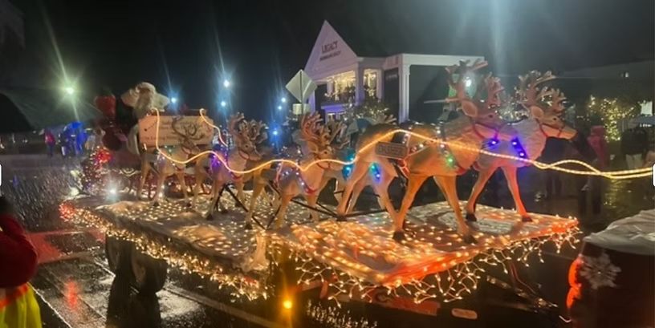

 2026 PARADE GUIDELINES
Registration: All parade entries must be pre-approved by the Parade Committee. Organizations are responsible for educating their participants of Parade rules and regulations.
Entry contact person on application must read, abide by the following, acknowledge they have read and understand guidelines in the application. They are also responsible for ensuring the rest of the entry participants understand and abide by the information below.
Parade Route: The parade will begin at Laconia High School at 4:30 PM. It will begin by taking a left onto Union Ave, then head down Church Street, then take a left through downtown against the direction of normal traffic down Main Street toward Stewart Park.
More details about arrival time, etc. will be sent via email closer to the date of the parade.
Make sure your vehicle can travel the entire route – especially important for oversized vehicles.
Acceptable Entries: Parade staff reserve the right to withdraw any parade entry that is offensive, illegal, or otherwise not reflective of Celebrate Laconia and its purpose for the parade. Entries that are not consistent with promotion of the theme or spirit will be denied.
Vehicle Dimensions: All vehicles or floats must be no wider than 10 feet; no longer than 60 feet; and no taller than ten feet. No projections off the body of the float (i.e. opened doors) will be permitted. Trailers and 18 wheelers are acceptable.
Costumes: We encourage everyone to dress up and enjoy the holiday season.
**There is only one Santa allowed in the parade, no one within your party may be dressed as Santa.**
Float Contest: We are pleased to announce that we will be having a float contest! There will be an entry fee of $50 per float. You can have a float and not participate in the contest. If you participate you will need to display a sign designating your contestant entry number provided by Celebrate Laconia on your float. Designate on your application that you would like to enter the contest by checking the box.
The guidelines remain the same as above under Acceptable Entries. There will be one Grand Prize Winner.
You can register and pay the entry fee right on the Celebrate Laconia webpage. Look under the Events tab for the Parade. To pay by check, please mail checks (payable to Celebrate Laconia with a memo of “Float Contest”) to Celebrate Laconia, PO Box 6502, Laconia, NH 03247. If you have any questions, please contact Celebrate Laconia at connect@celebratelaconia.org
Display Requirements: All entries must display at least one sign/banner naming the organization. If you are participating in the float contest, you will also need display your float contest number for voting purposes. Celebrate Laconia will provide you with your contest number.
Decoration Requirements: Affix decorations to vehicle prior to arriving Downtown for the event. Decorations on vehicles should be securely attached to the vehicles to prevent them flying off and injuring participants, other vehicles or bystanders.
Music/Sound: Any music played must be radio edited - no inappropriate or foul language. Entries with obscene language or inappropriate implications will be removed from the parade.
Alcohol: Alcoholic beverages are not allowed on or in any entry vehicle. No consumption of alcoholic beverages by parade participants will be permitted before or during the parade.

Safety: All entries must travel the entire length of the parade. Motorized vehicles must be registered and have a certificate of insurance. All vehicles must be road safe. Towed entries must have a rigid hitch and safety chains. Constructions deemed unsafe to participants or dangerous to bystanders will be denied.
**Participants on floats must remain seated at all times on the floats. Participants cannot be getting on/off the floats during the parade.**
Parade Flow and Movement: To keep the parade moving at a reasonable pace and for their safety all children under the age of 5 MUST be in a stroller, wagon or sitting on a float for the duration of the parade.
Hand-outs and Considerations: If you are providing objects to the crowd, they must be passed directly. Do not throw or toss objects during the parade. In addition, all candy must be individually wrapped, no chocolate. NO GLITTER!
By submitting the holiday parade application, the applicant agrees to defend, indemnify and hold harmless Celebrate Laconia, its members, representatives and agents, from and against any and all liability, loss, cost, damage and expenses, including costs and attorney fees in defense thereof because of actions, claims, or lawsuits for damages resulting from personal or alleged to have been sustained by any person or persons and on account of damage to property, arising or alleged to have arisen directly or indirectly out of or in consequence of the applicant’s participation in Celebrate Laconia Lights Festival Holiday Parade.

